### **Tracing The Growth Of The Global Community: A Population Forecasting  Analysis**

1. INTRODUCTION:

1.1OVERVIEW

The world’s population is more than three times larger than it was in the mid-twentieth century. The global human population reached 8.0 billion in mid-November 2022 from an estimated 2.5 billion people in 1950, adding 1 billion people since 2010 and 2 billion since 1998. The world’s population is expected to increase by nearly 2 billion persons in the next 30 years, from the current 8 billion to 9.7 billion in 2050 and could peak at nearly 10.4 billion in the mid-2080s.

This dramatic growth has been driven largely by increasing numbers of people surviving to reproductive age, the gradual increase in human lifespan, increasing urbanization, and accelerating migration. Major changes in fertility rate have accompanied this growth. These trends will have far-reaching implications for generations to come.

2.2PURPOSE

In the context of ‘Tracing the growth of a global community’ a literature survey would involve reviewing studies and articles that have been published on the topic of population and  demographics, as well as studies specific population increase in cities.It would aim to identify key performance indicators.

2. PROBLEM DEFINITION AND DESIGN THINKING:

2.1 EMPATHY MAP

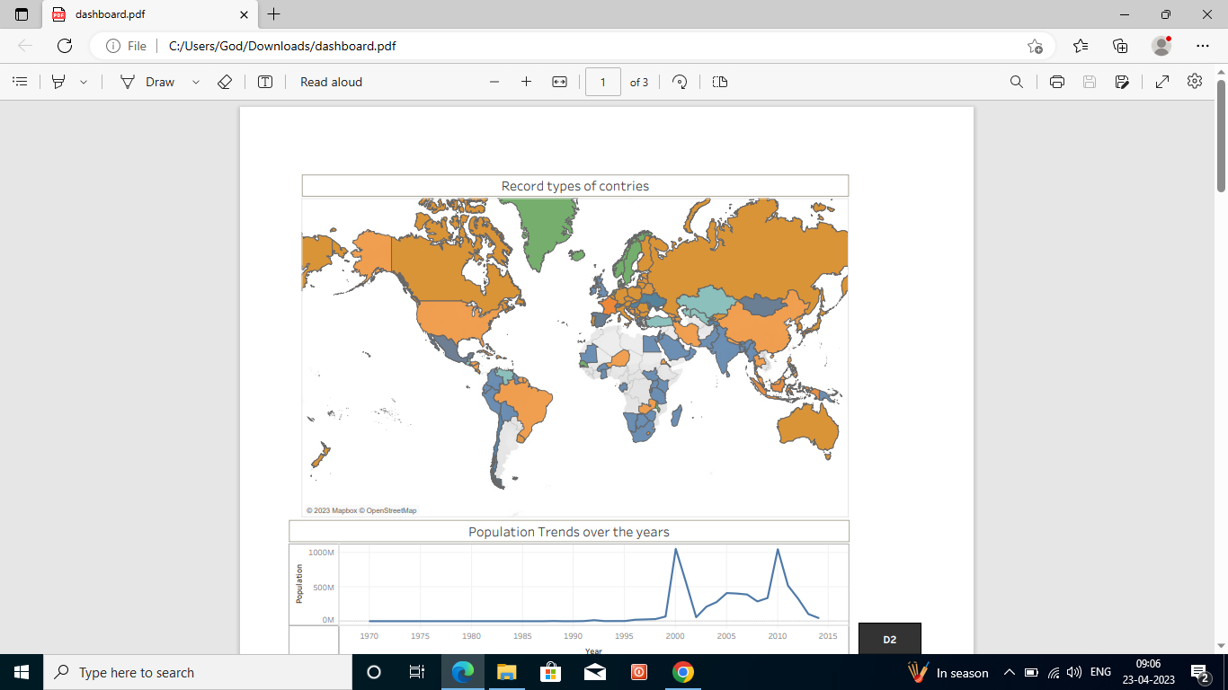

2.2 IDEATION &BRAINSTORMING MAP

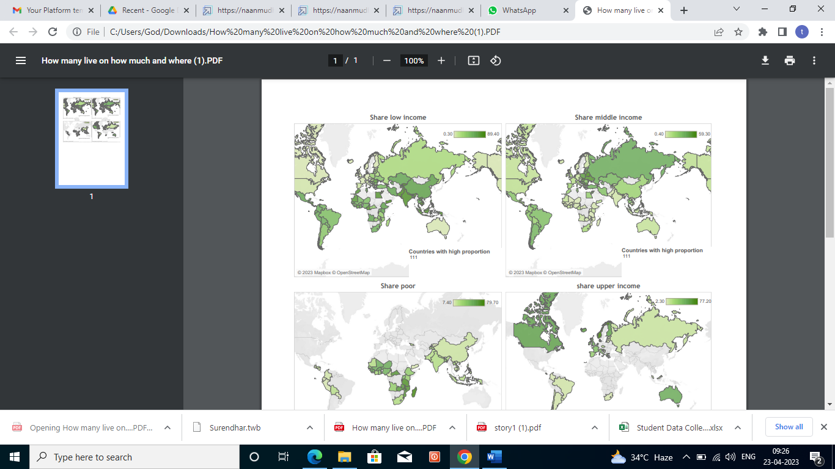

3. RESULT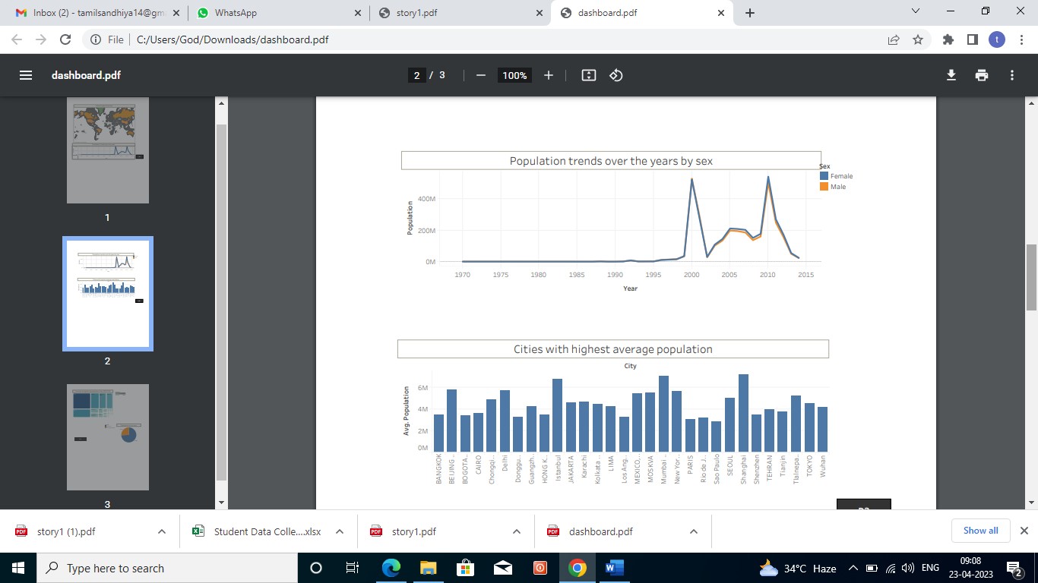T

ADVANTAGES & DISADVANTAGES:

It is easy to calculate the population of each and every city

It is comfort to access data by our requirements

It is very difficult to know our mistake in data entry

APPLICATION:

It is used in many areas in worldwide to know the population of strategy according to our categories

CONCULSION:.

Tracing the growth of the global community and analysing the growth of population in the worldwide

We find a rapid growth in the world population.we categories all type of problems and data according to the public requirement.

FUTURE SCOPE:

The future work of our project is to develop the work to other object like demand of food, ,water, power and transportation.